Asia Pacific College

School of Computer and Information Technology

Applied Projects 2

**Colegio Monterei de Pila**

**User Manual**

Prepared by:

Jhun Michael Tabudlong

Angelo Costales

Cerjei Canamaque

Marc Dave Mendoza

1. **System Overview**

The system is to have a collaborative means of communication with the faculty, wherein they could upload the grades and have an easy access to view it with the other subject teachers and advisers. Thus, helping them to compute the grades faster. The students and parents will also have an access to the system to view the grades quarterly.

Online grades is to be done for the use of teachers in Colegio Monterei de Pila strengthen data integrity and to lighten work for the people who work on student's grades in the school. One of the major feature of the project is having the teachers update the quarterly grade of the student, the grade can be viewed by the parents/students online.

1. **Application**

Major Functionalities of the system:

**Online grade submission** – Teachers can directly encode the final grade on the online system.

**Online grade viewer** – Student/parent can directly view and print the grade using the online system.

**School Facility Viewing** – This is where the school facility will be shown on the gallery section of the website.

1. **Dialog Flow**

**Login & Password** - These are the credentials the user should use to view or to edit.

**CMP Web Address** - This is the URL where user will be accessible once copied to the web server. It should be supplied whether you are transferring files to the web via a local file share or FTP server.

**Server Type**: This is the database server type. Currently the only database servers supported are MySQL.

1. **User Operation Manual**

* **Main Homepage**

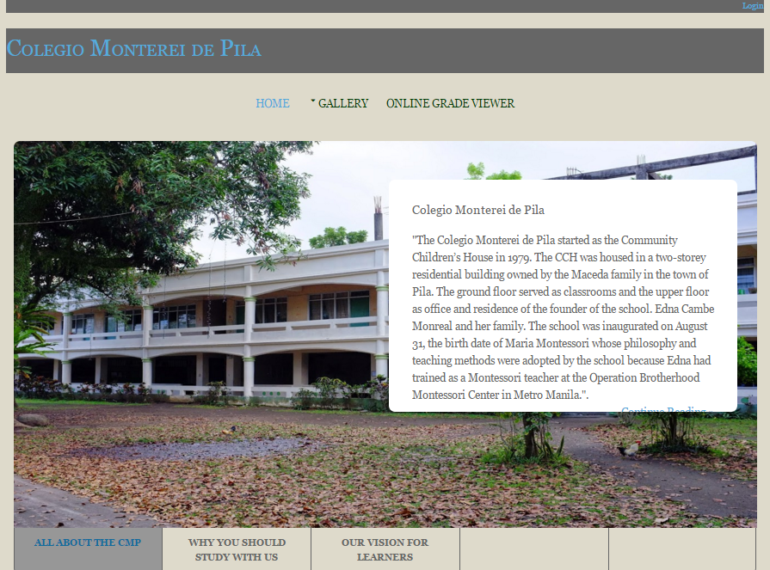

* **School Gallery**

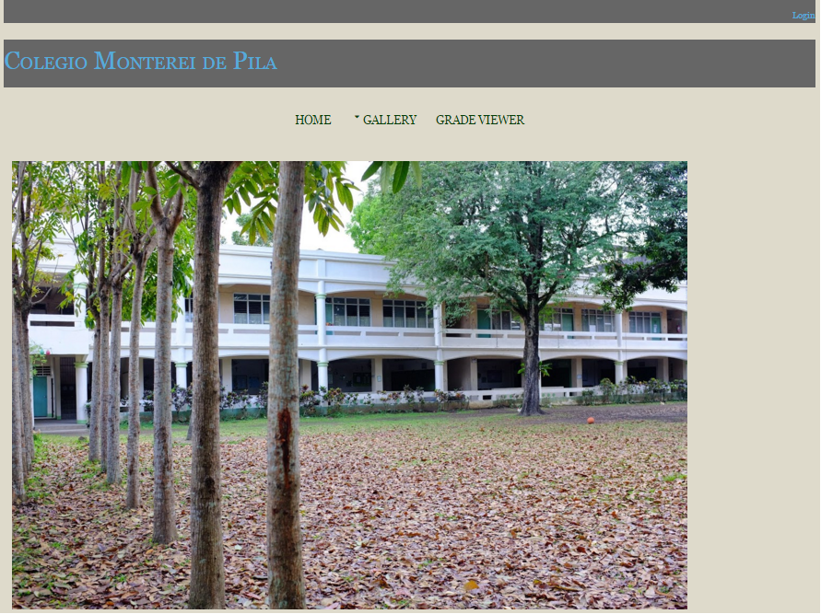

* **User Login (Administrator)**

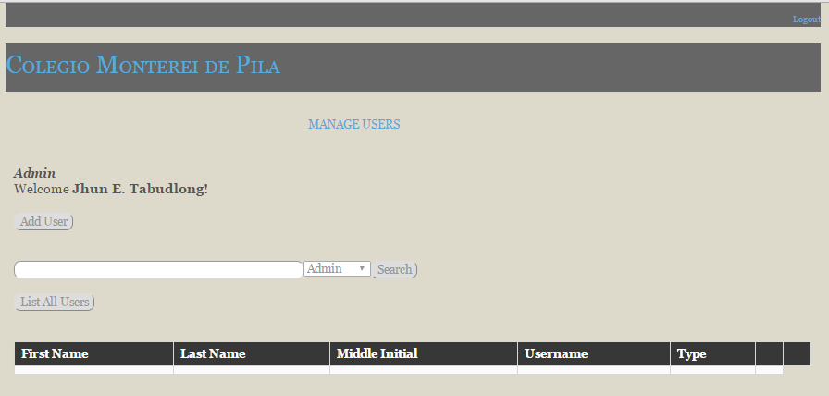

* **Account Creation (Administrator)**

1. After successfully logging in as an admin. Click the “Add User” button.
2. All you need to do is to fill up all of the blank fields, and you can also choose whether it is a student, admin, or a teacher.
3. You can also assign here which section should the student and teacher should be assigned.

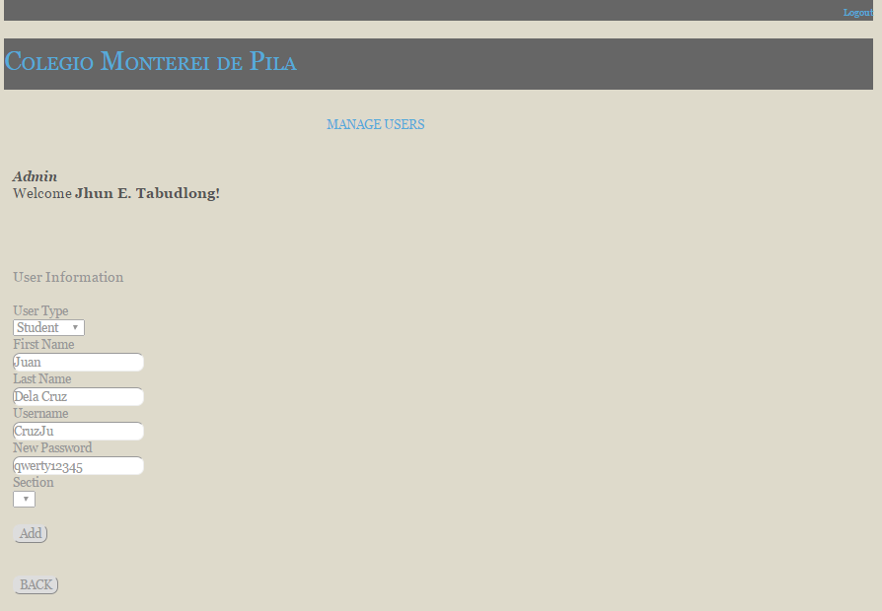

* **Account Creation Checking**

1. Once you’ve successfully created a new account, you can check it by clicking the “List All Users” button.
2. If you want change some of the user’s information just click the “EDIT” button, and if you want to delete the user just click the “DELETE” button.

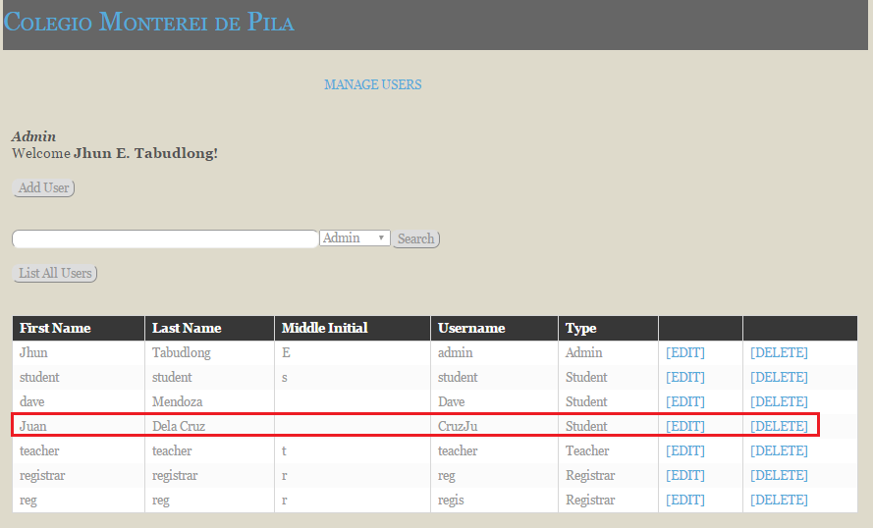

1. Account Update (EDIT)

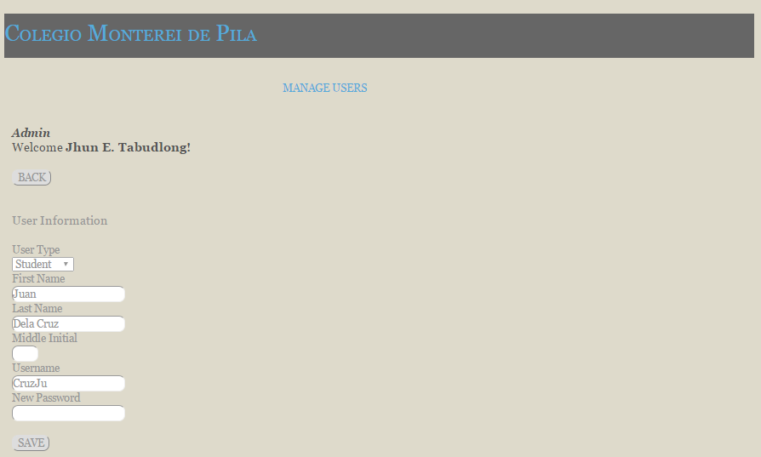

**User Login (Teacher)**

1. Make sure the teacher’s account has been created by the admin.
2. Teacher has been assigned on a specific year and section with the subjects listed in there. To manage the grades of the students just click the “MANAGE CLASS” button.

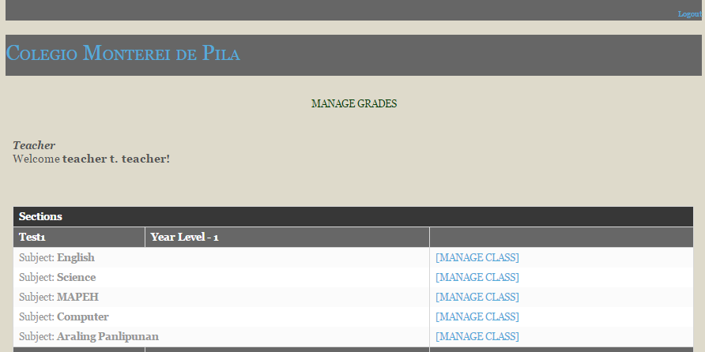

**Grade Submission (Teacher)**

1. After clicking the “MANAGE CLASS” button, this is the page that you should be heading.
2. The list of all students of this class should be listed, where you can input their quarterly grades.

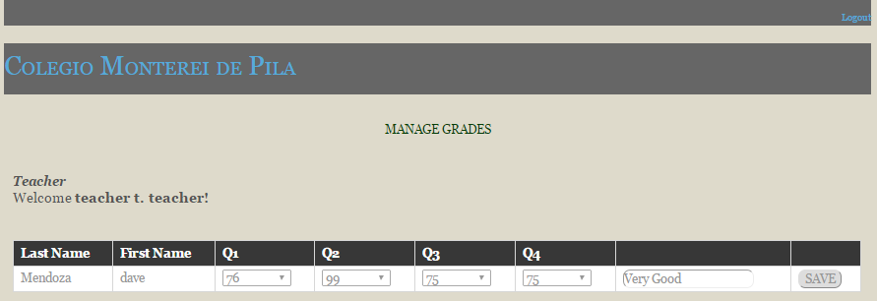

* **User Login (Student/Parent)**

1. Make sure that the account of student has been create by the admin.
2. This is where you should enter the unique account that has been given to you by the admin.

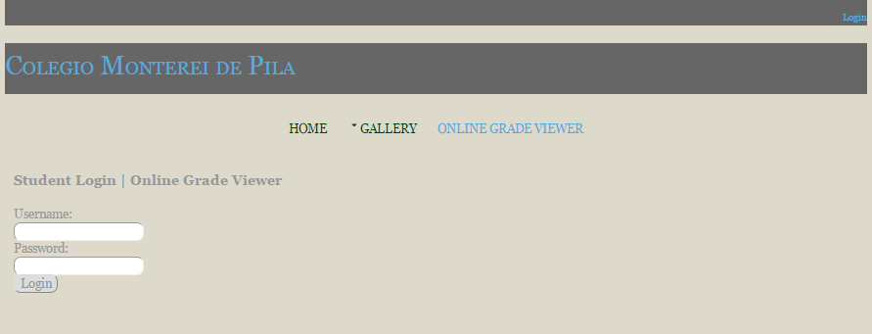

* **Onlige grade viewing**

1. After successfully logging in, the student should be able to see the final grades submitted by his teacher.

